**Amazon Data Sales Analysis**

**Overview :**

In this Amazon Data Analysis Project We Have to Analize Amazon Sales Data with the goal of identify sales trend month wise and year wise to increase the profit and reduce the loss for the organization

The Project Aims to give actionable insights to organization to make Better Strategies with historical Data

**Objective :**

* Analyze Amazon Sales Data Month-Wise And Year-Wise
* Identify Patterns and trends Sales Over Time
* Provide a solution to increase profit and reduce a loss

**Business Problem :**

Sales Managemant has gained importance to meet increasing competition and the need for improved methods of distribution to reduces the cost and incresing profit

**Data Collection :**

Amazon Sales Data Is Provided By I Neuron

**Data Cleaning And Preparation:**

Cleaned and preprocess the data , handle missing value and date column

Transform the data in suitable For Analysis

**Visualization :**

Done Eda In Jupyter Notebook and Made a Intractive dashboard in power BI

**Architecture :**

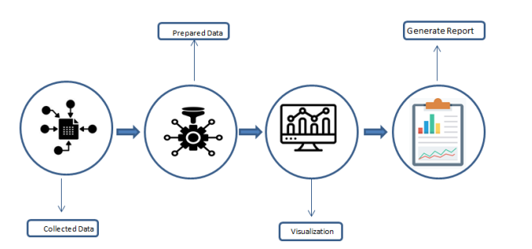

**Conclusion**

* When Discount is getting low sales also down
* Some Product is not being sold since long we should remove from inventory
* Some Product Cost of sell is high and solding in loss , this product covering more losses
* Top Product Giving more profit and Margin